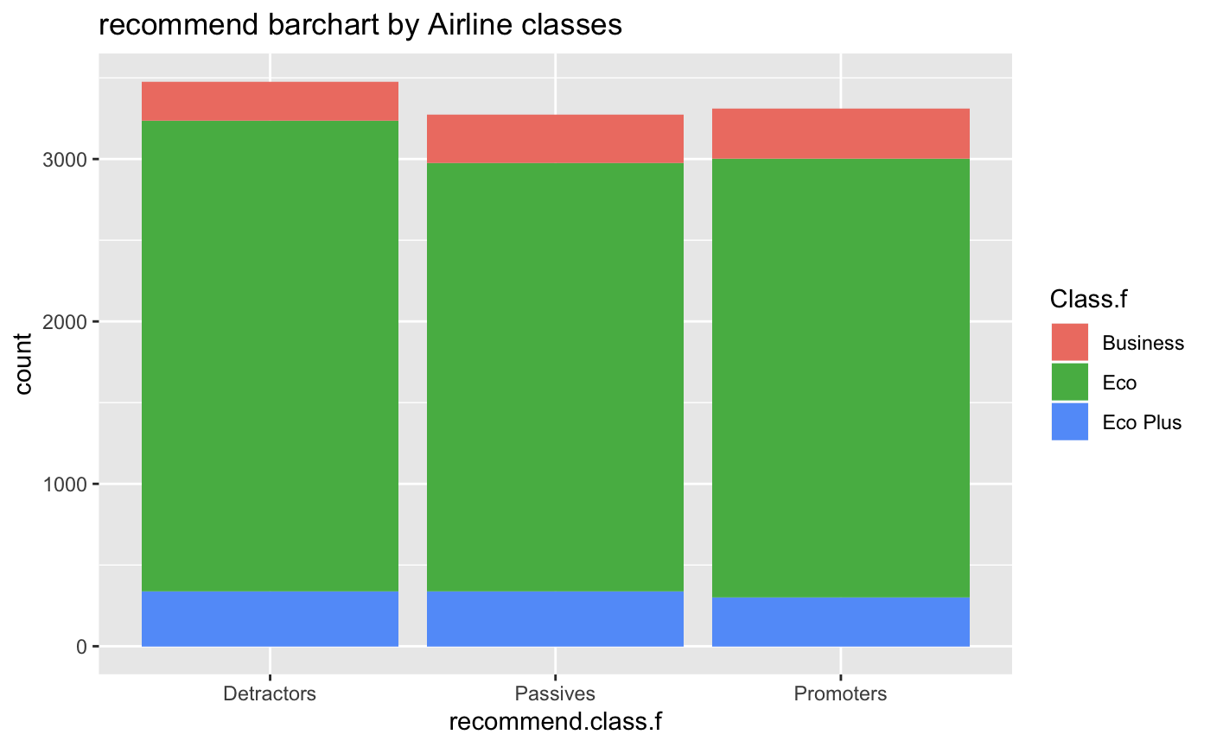

ggplot(data_clean,aes(recommend.class.f)) +

geom_bar(aes(fill = Class.f)) +

ggtitle("recommend barchart by Airline classes")

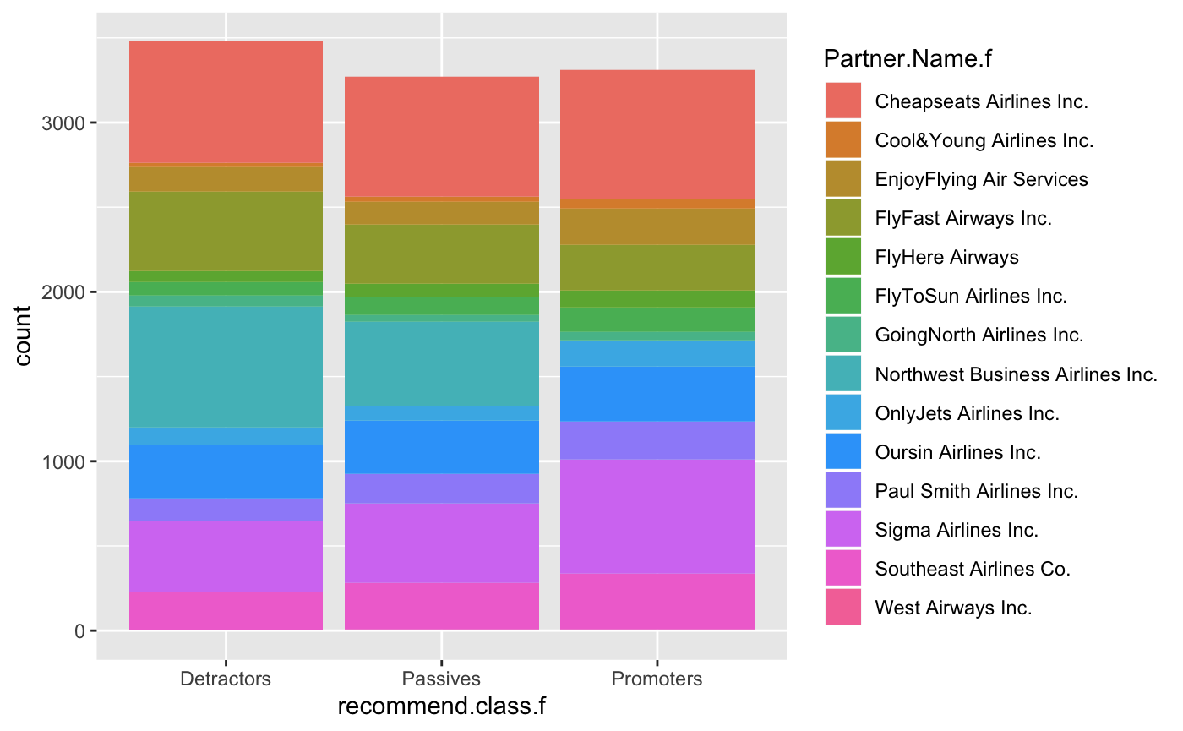

ggplot(data_clean,aes(recommend.class.f)) +

geom_bar(aes(fill = Partner.Name.f))

Type of Customers vs. Type of Travel (EXCEL)

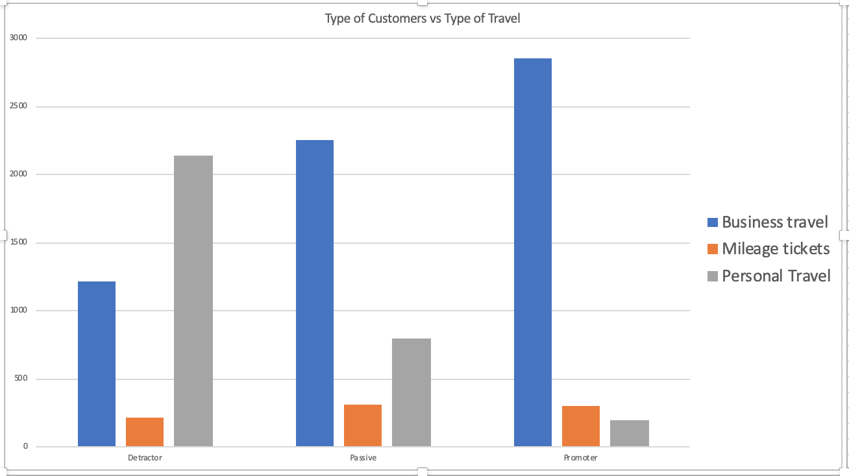

Likelihood.to.recommend vs type of travel (EXCEL)

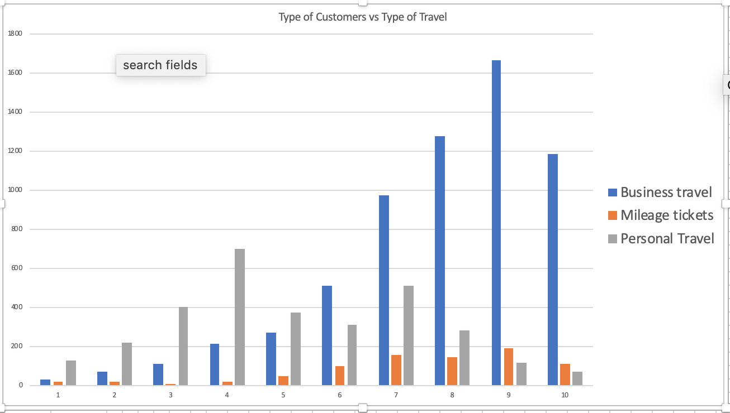

Type of Customers vs airline status(EXCEL)

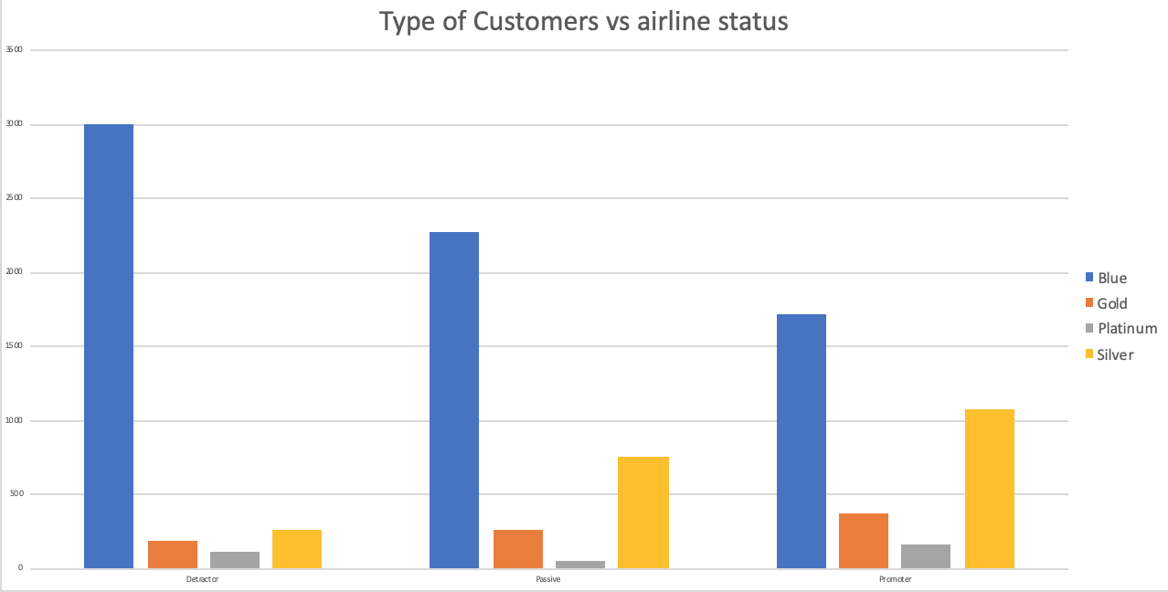

# correlation plot

I removed some variables which I thought were not important and ran a correlation.

This is the correlation plot

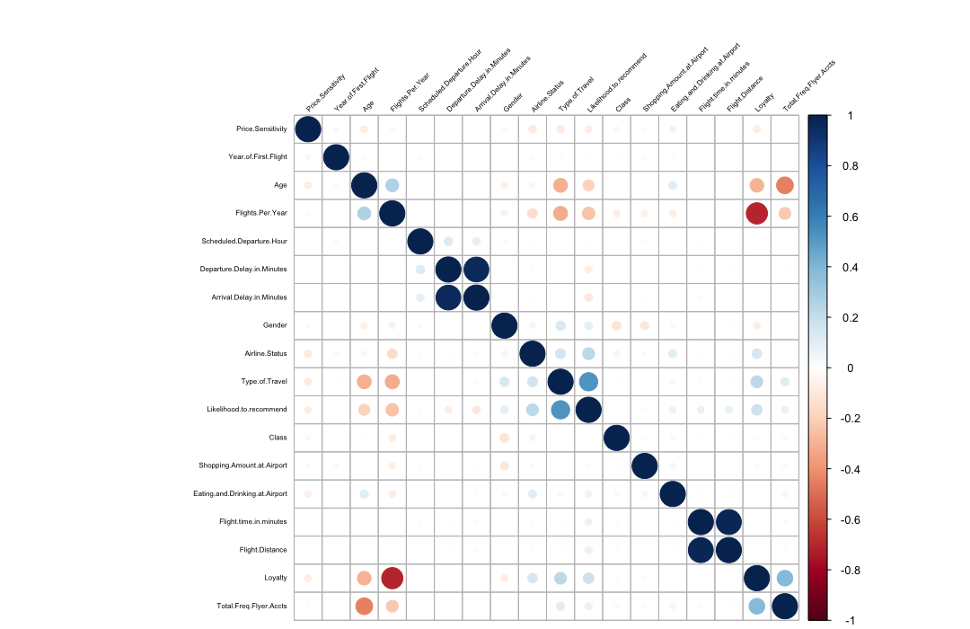

For the first reference of which variables are significant before running linear model or arules:

From this plot for likelihood to recommend there are 13 variables are significant

1. Price sensitivity, age, flights per year, departure delay in minutes, arrival delay in minutes are negatively related
2. Gender, airline status, type of travel, eating and drinking at airport, flight time in minutes, flight distance, loyalty, total freq flyer accts are positively related